
Safeguarding Policy Document

Contents
1. Introduction 3
2. Recognising and responding to actual or suspected abuse 3
Understanding abuse and neglect 3
Safeguarding awareness 3
Responding to allegations or suspicions of abuse 4
Online Safety 4
3. Recruitment, support and supervision of workers 4
4. Pastoral care 4
Supporting those affected by abuse 4
Working with offenders 4
5. Miscellaneous 4
Responsible persons 4
Working with other organisations 5
Publicity 5
Annexes 5
Annex A: Recognising abuse 6
Statutory Definitions of Abuse (Children) 6
Further Definitions of Abuse (Children) 7
Signs of Possible Abuse (children & young people) 10
Signs of Possible Abuse (Adults) 10
Annex B: Responding to allegations of abuse 13
General procedure 13
Detailed procedures where there is a concern about a child: 15
Detailed procedures where there is a concern that an adult is in need of protection: 15
Allegations of abuse against a person who works with children/young people 15
Allegations of abuse against a person who works with adults with care and support needs. 16
Contact information 16
Immediate Danger to a Child 16
Immediate Concerns about a Child 16
Annex C: Online Safety Code of Conduct 18
Annex D: Cause for Concern Report 20
Annex E: Recruitment of Voluntary Workers 21
Annex F: Practice Guidelines when working with children 22
General principles 22
Touching children 22
Supervision rules 22
Specific procedures 22
Recording incidents 23
Additional rules for particular activities or events 23
Annex G: Leadership Safeguarding Statement 24
Annex H: Recruitment of Voluntary Workers Application Form. 26
Annex I: Consent Form 28
Annex J: Activities and Day Visits Consent Form 29
Annex K: Incident Form 30

Safeguarding Policy for Wantage Baptist Church

1. Introduction
Wantage Baptist Church has a significant ministry aimed at children and young people. It also engages with adults who may be vulnerable. This document sets out the policy adopted by the Elders and Deacons of the Church (hereafter known as “the Leadership”) for safeguarding the interests of all children and vulnerable adults with whom the church comes into contact.
We recognise the need to provide a safe and caring environment for children, young people and vulnerable adults. We acknowledge that children, young people and vulnerable adults can be the victims of physical, sexual and emotional abuse, financial abuse and neglect.
We accept the UN Universal Declaration of Human Rights and the International Covenant of Human Rights, which states that everyone is entitled to “all the rights and freedoms set forth therein, without distinction of any kind, such as race, colour, sex, language, religion, political or other opinion, national or social origin, property, birth or other status”. We also concur with the Convention on the Rights of the Child which states that children should be able to develop their full potential, free from hunger and want, neglect and abuse. They have a right to be protected from “all forms of physical or mental violence, injury or abuse, neglect or negligent treatment or exploitation, including sexual abuse, while in the care of parent(s), legal guardian(s), or any other person who has care of the child.” As a Leadership we have therefore adopted the procedures set out in this safeguarding policy in accordance with statutory guidance. We are committed to build constructive links with statutory and voluntary agencies involved in safeguarding.
This policy, and the way in which it has been applied, will be reviewed annually and updated or improved as required.

2. Recognising and responding to actual or suspected abuse

Understanding abuse and neglect
Defining child abuse or abuse against a vulnerable adult is a difficult and complex issue. A person may abuse by inflicting harm or failing to prevent harm. Children and adults in need of protection may be abused within a family, an institution or a community setting. Very often the abuser is known or in a trusted relationship with the child or adult.
We accept the detailed definitions of abuse set out in Annex A. That annex also describes typical signs and symptoms of abuse.

Safeguarding awareness
The Leadership is committed to on-going safeguarding training and development opportunities for all those working with children or vulnerable adults, and to developing a culture of awareness of safeguarding issues to help protect everyone.
The Leadership will also ensure that children and vulnerable adults are provided with information on where to get help and advice in relation to abuse, discrimination, bullying or any other matter where they have a concern.

Responding to allegations or suspicions of abuse
Where abuse is alleged or suspected, we are committed to ensuring that this is dealt with appropriately. Annex B sets out our procedures for achieving this. We will fully co-operate with any statutory investigation into suspected abuse linked with the church.

Online Safety
Online safety is the collective term for safeguarding involving the use of electronic devices and applications to communicate and access the Internet; often referred to as Information and Communications Technology. Annex C sets out our code of conduct for all church workers when using online communications.

3. Recruitment, support and supervision of workers
As an organisation working with children, young people and vulnerable adults we wish to operate and promote good working practice. This will enable workers to run activities safely, develop good relationships and minimise the risk of false or unfounded accusations.
Accordingly, we will ensure all workers are appointed, trained, supported and supervised in accordance with recognised good practice. Annex E sets out detailed provisions on these matters.
Annex F sets out a general code of conduct for all our workers, together with good practice guidelines for every activity we are involved in.

4. Pastoral care

Supporting those affected by abuse
The Leadership is committed to offering pastoral care, working with statutory agencies as appropriate, and support to all those who have been affected by abuse who have contact with or are part of the church.

Working with offenders
When someone attending the church is known to have abused children or is known to be a risk to vulnerable adults, the Leadership will supervise the individual concerned and offer pastoral care, but in its safeguarding commitment to the protection of children and vulnerable adults, set boundaries for that person which they will be expected to keep.

5. Miscellaneous

Responsible persons
The Leadership has overall responsibility for safeguarding matters within the church. However, they have appointed a Safeguarding Team with particular responsibilities for implementing this policy. The current members of this team are listed in Annex B.
The Leadership is committed to supporting the Safeguarding Team in their work and in any action they may need to take in order to protect children and vulnerable adults.

Working with other organisations
The Church also works with other organisations and allows its premises to be used by other organisations. We are committed to ensuring that such organisations have suitable safeguarding policies and procedures where appropriate.

Publicity
We will make information about safeguarding available to all those involved in church activities. This includes a written statement (Annex G) that will be posted to the church notice boards and website, ensuring that all group leaders have read a copy of the policy and publishing the details of where to obtain a copy of the policy.

Annexes
- Recognising abuse
- Responding to allegations of abuse
- Online safety code of conduct
- Cause for concern reporting
- Recruitment of voluntary workers
- Practice guidelines when working with children
- Leadership safeguarding statement
- Recruitment of voluntary workers application form
- Consent form
- Activities and day visits consent form
- Incident form

Annex A: Recognising abuse

Statutory Definitions of Abuse (Children)
Child protection legislation throughout the UK is based on the United Nations Convention on the Rights of the Child. The four definitions of abuse below operate in England based on the government guidance ‘Working Together to Safeguard Children (2015)’.
What is abuse and neglect?
Abuse and neglect are forms of maltreatment of a child. Somebody may abuse or neglect a child by inflicting harm, or by failing to act to prevent harm. Children may be abused in a family or in an institutional or community setting, by those known to them or, more rarely, by a stranger for example, via the internet. They may be abused by an adult or adults, or another child or children.
Physical abuse
Physical abuse may involve hitting, shaking, throwing, poisoning, burning or scalding, drowning, suffocating, or otherwise causing physical harm to a child. Physical harm may also be caused when a parent or carer fabricates the symptoms of, or deliberately induces, illness in a child.
Emotional abuse
Emotional abuse is the persistent emotional maltreatment of a child such as to cause severe and persistent adverse effects on the child’s emotional development. It may involve conveying to children that they are worthless or unloved, inadequate, or valued only insofar as they meet the needs of another person. It may include not giving the child opportunities to express their views, deliberately silencing them or ‘making fun’ of what they say or how they communicate. It may feature age or developmentally inappropriate expectations being imposed on children. These may include interactions that are beyond the child’s developmental capability, as well as overprotection and limitation of exploration and learning, or preventing the child participating in normal social interaction. It may involve seeing or hearing the ill-treatment of another. It may involve serious bullying (including cyberbullying), causing children frequently to feel frightened or in danger, or the exploitation or corruption of children. Some level of emotional abuse is involved in all types of maltreatment of a child, though it may occur alone.
Sexual abuse
Sexual abuse involves forcing or enticing a child or young person to take part in sexual activities, not necessarily involving a high level of violence, whether or not the child is aware of what is happening. The activities may involve physical contact, including assault by penetration (for example, rape or oral sex) or non-penetrative acts such as masturbation, kissing, rubbing and touching outside of clothing. They may also include non-contact activities, such as involving children in looking at, or in the production of, sexual images, watching sexual activities, encouraging children to behave in sexually inappropriate ways, or grooming a child in preparation for abuse (including via the internet). Sexual abuse is not solely perpetrated by adult males. Women can also commit acts of sexual abuse, as can other children.
Neglect
Neglect is the persistent failure to meet a child’s basic physical and/or psychological needs, likely to result in the serious impairment of the child’s health or development. Neglect may occur during pregnancy as a result of maternal substance abuse. Once a child is born, neglect may involve a parent or carer failing to:
- Provide adequate food, clothing and shelter (including exclusion from home or abandonment);
- Protect a child from physical and emotional harm or danger;
- Ensure adequate supervision (including the use of inadequate care-givers); or
- Ensure access to appropriate medical care or treatment.
It may also include neglect of, or unresponsiveness to, a child’s basic emotional needs.

Further Definitions of Abuse
Significant Harm
This relates to the degree of harm that triggers statutory action to protect a child. It is based on the individual child's health or development compared to that which could reasonably be expected of a similar child. E.g. severity of ill treatment, degree and extent of physical harm, duration and frequency of abuse and neglect, premeditation. Department of Health guidance suggests that 'significant' means 'considerable, noteworthy or important.'
Children in Whom Illness is Fabricated or Induced (formerly known as Munchausen’s Syndrome By Proxy)
This is a form of child abuse in which the parents or carers give false accounts of symptoms in their children and may fake signs of illness (to draw attention to themselves). They seek repeated medical investigations and needless treatment for their children. The government guidance on this is found in 'Safeguarding Children in whom Illness is Fabricated or Induced' (2002).
Spiritual Abuse
Linked with emotional abuse, spiritual abuse could be defined as an abuse of power, often done in the name of God or religion, which involves manipulating or coercing someone into thinking, saying or doing things without respecting their right to choose for themselves. Some indicators of spiritual abuse might be a leader who is intimidating and imposes his/her will on other people, perhaps threatening dire consequences or the wrath of God if disobeyed. He or she may say that God has revealed certain things to them and so they know what is right. Those under their leadership are fearful to challenge or disagree, believing they will lose the leader's (or more seriously God's) acceptance and approval.
In 2013 spiritual abuse was defined as “Spiritual abuse is coercion and control of one individual by another in a spiritual context. The target experiences spiritual abuse as a deeply emotional personal attack. This abuse may include:-manipulation and exploitation, enforced accountability, censorship of decision making, requirements for secrecy and silence, pressure to conform, misuse of scripture or the pulpit to control behaviour, requirement of obedience to the abuser, the suggestion that the abuser has a ‘divine’ position, isolation from others, especially those external to the abusive context.”(Oakley & Kinmond, 2013)
Domestic Violence
The shared Association of Chief Police Officers (ACPO), Crown Prosecution Service (CPS) and government definition of domestic violence is: ‘any incident of threatening behaviour, violence or abuse (psychological, physical, sexual, financial or emotional) between adults, aged 18 and over, who are or have been intimate partners or family members, regardless of gender and sexuality.’ (Family members are defined as mother, father, son, daughter, brother, sister and grandparents, whether directly related, in-laws or step-family.)
In 2004 the Government’s definition of domestic violence was extended to include acts perpetrated by extended family members as well as intimate partners. Consequently, acts such as forced marriage and other so-called ‘honour crimes’, which can include abduction and homicide, can now come under the definition of domestic violence.
The Government revised its definition of domestic violence and abuse in March 2013 as:
"Any incident or pattern of incidents of controlling coercive or threatening behaviour, violence or abuse between those aged 16 or over who are or have been intimate partners or family members, regardless of gender or sexuality."
This can encompass, but is not limited to, the following types of abuse: Psychological; Physical; Sexual; Financial; Emotional.
"Controlling behaviour is: a range of acts designed to make a person subordinate and/or dependant by isolating them from sources of support, exploiting their resources and capacities for personal gain, depriving them of the means needed for independence, resistance and escape and regulating their everyday behaviour."
"Coercive behaviour is: an act or a pattern of acts of assaults, threats, humiliation and intimidation or other abuse that is used to harm, punish, or frighten their victim."
Family members are defined as mother, father, son, daughter, brother, sister and grandparents whether directly related, in-laws or step-family. However, this is not an exhaustive list and may also be extended to uncles, aunts and cousins etc.
The Home Office (2009) What is Domestic Violence? London: Home Office defines domestic violence as:
“Any incident of threatening behaviour, violence or abuse (psychological, physical, sexual, financial or emotional) between adults who are or have been intimate partners or family members, regardless of gender or sexuality”
Nearly a quarter of adults in England are victims of domestic violence. Although both men and women can be victimised in this way, a greater proportion of women experience all forms of domestic violence, and are more likely to be seriously injured or killed by their partner, ex-partner or lover. Forced marriage and honour-based violence are human rights abuses and fall within the Government’s definition of domestic violence.
Complex (organised or multiple) abuse
Complex abuse may be defined as abuse involving one or more abusers and a number of children. The abusers concerned may be acting in concert to abuse children, sometimes acting in isolation, or may be using an institutional framework or position of authority to recruit children for abuse.
Complex abuse occurs both as part of a network of abuse across a family or community, and within institutions such as residential homes or schools. Such abuse is profoundly traumatic for the children who become involved. Its investigation is time-consuming and demanding work, requiring specialist skills from both police and social work staff. Some investigations become extremely complex because of the number of places and people involved, and the timescale over which abuse is alleged to have occurred. The complexity is heightened where, as in historical cases, the alleged victims are no longer living in the setting where the incidents occurred or where the alleged perpetrators are also no longer linked to the setting or employment role. (Working Together 2010 Sections: 6.10 – 6.11)

Sexually exploited children and young people
The Sexual Offences Act 2003 introduced a number of new offences to deal with those who sexually exploit children and young people. The offences protect children up to the age of 18 and can attract tough penalties. They include:
- Paying for the sexual services of a child;
- Causing or inciting child prostitution;
- Arranging or facilitating child prostitution; and
- Controlling a child prostitute.
Children who are sexually exploited into prostitution
'Working Together to Safeguard Children' (2006) Section 6.2 stated:
Children involved in prostitution and other forms of commercial sexual exploitation should be treated primarily as the victims of abuse, and their needs require careful assessment.
Female Genital Mutilation (FGM)
The World Health Organization defined FGM as all procedures involving partial or total removal or stitching up of the female genitalia or other injury to the female genital organs whether for cultural or other non-therapeutic reasons.
Working Together (2010) stated that:
“Female genital mutilation (FGM) is a collective term for procedures which include the removal of part or all of the external female genitalia for cultural or other nontherapeutic reasons. The practice is medically unnecessary, extremely painful and has serious health consequences, both at the time when the mutilation is carried out and in later life. The procedure is typically performed on girls aged between four and thirteen, but in some cases FGM is performed on new born infants or on young women before marriage or pregnancy. A number of girls die as a direct result of the procedure from blood loss or infection, either following the procedure or subsequently in childbirth.”
FGM has been a criminal offence in the UK since the Prohibition of Female Circumcision Act 1985 was passed. The Female Genital Mutilation Act 2003 replaced the 1985 Act and made it an offence for UK nationals or permanent UK residents to carry out FGM abroad, or to aid, abet, counsel or procure the carrying out of FGM abroad, even in countries where the practice is legal.
A mandatory reporting duty for FGM requires regulated health and social care professionals and teachers in England and Wales to report known cases of FGM in under 18-year-olds to the police. The FGM duty came into force on 31 October 2015.

Signs of Possible Abuse (children & young people)
The following signs could be indicators that abuse has taken place but should be considered in context of the child’s whole life.
Physical
- Injuries not consistent with the explanation given for them
- Injuries that occur in places not normally exposed to falls, rough games, etc
- Injuries that have not received medical attention
- Reluctance to change for, or participate in, games or swimming
- Repeated urinary infections or unexplained tummy pains
- Bruises on babies, bites, burns, fractures etc which do not have an accidental explanation*
- Cuts/scratches/substance abuse*
*These indicate the possibility that a child or young person is self-harming. Approximately 20,000 are treated in accident and emergency departments in the UK each year.
Sexual
- Any allegations made concerning sexual abuse
- Excessive preoccupation with sexual matters and detailed knowledge of adult sexual behaviour
- Age-inappropriate sexual activity through words, play or drawing
- Child who is sexually provocative or seductive with adults
- Inappropriate bed-sharing arrangements at home
- Severe sleep disturbances with fears, phobias, vivid dreams or nightmares, sometimes with overt or veiled sexual connotations
- Eating disorders - anorexia, bulimia*
Emotional
- Changes or regression in mood or behaviour, particularly where a child withdraws or becomes clinging.
- Depression, aggression, extreme anxiety.
- Nervousness, frozen watchfulness
- Obsessions or phobias
- Sudden under-achievement or lack of concentration
- Inappropriate relationships with peers and/or adults
- Attention-seeking behaviour
- Persistent tiredness
- Running away/stealing/lying
Neglect
- Undernourishment, failure to grow, constant hunger, stealing or gorging food
- Untreated illnesses
- Inadequate care, etc

Signs of Possible Abuse (Adults)
Physical abuse
- History of unexplained falls, fractures, bruises, burns, minor injuries.
- Signs of under or over use of medication and/or medical problems left unattended.
- Any injuries not consistent with the explanation given for them
- Bruising and discolouration - particularly if there is a lot of bruising of different ages and in places not normally exposed to falls, rough games etc.
- Recurring injuries without plausible explanation
- Loss of hair, loss of weight and change of appetite
- Person flinches at physical contact &/or keeps fully covered, even in hot weather;
- Person appears frightened or subdued in the presence of a particular person or people
Domestic violence (ages 16+)
- Unexplained injuries or ‘excuses’ for marks or scars
- Controlling and/or threatening relationship including psychological, physical, sexual, financial, emotional abuse; so called ‘honour’ based violence and Female Genital Mutilation.
Sexual abuse
- Pregnancy in a woman who lacks mental capacity or is unable to consent to sexual intercourse
- Unexplained change in behaviour or sexually explicit behaviour
- Torn, stained or bloody underwear and/or unusual difficulty in walking or sitting
- Infections or sexually transmitted diseases
- Full or partial disclosures or hints of sexual abuse
- Self-harming
- Emotional distress
- Mood changes
- Disturbed sleep patterns
Psychological abuse
- Alteration in psychological state e.g. withdrawn, agitated, anxious, tearful
- Intimidated or subdued in the presence of a carer
- Fearful, flinching or frightened of making choices or expressing wishes
- Unexplained paranoia
- Changes in mood, attitude and behaviour, excessive fear or anxiety
- Changes in sleep pattern or persistent tiredness
- Loss of appetite
- Helplessness or passivity
- Confusion or disorientation
- Implausible stories and attention seeking behaviour
- Low self-esteem

Financial or material abuse
- Disparity between assets and living conditions
- Unexplained withdrawals from accounts or disappearance of financial documents or loss of money
- Sudden inability to pay bills, getting into debt
- Carers or professionals fail to account for expenses incurred on a person’s behalf
- Recent changes of deeds or title to property
- Missing personal belongings
- Inappropriate granting and / or use of Power of Attorney
Modern slavery
- Physical appearance; unkempt, inappropriate clothing, malnourished
- Movement monitored, rarely alone, travel early or late at night to facilitate working hours.
- Few personal possessions or ID documents.
- Fear of seeking help or trusting people.
Discriminatory abuse
- Inappropriate remarks, comments or lack of respect
- Poor quality or avoidance care
- Low self-esteem
- Withdrawn
- Anger
- Person puts themselves down in terms of their gender or sexuality
- Abuse may be observed in conversations or reports by the person of how they perceive themselves
Institutional Abuse
- Low self-esteem
- Withdrawn
- Anger
- Person puts themselves down in terms of their gender or sexuality
- Abuse may be observed in conversations or reports by the person of how they perceive themselves
- No confidence in complaints procedures for staff or service users.
- Neglectful or poor professional practice.
Neglect and acts of omission
- Deteriorating despite apparent care
- Poor home conditions, clothing or care and support.
- Lack of medication or medical intervention

Self-neglect
- Hoarding inside or outside a property
- Neglecting personal hygiene or medical needs
- Person looking unkempt or dirty and has poor personal hygiene
- Person is malnourished, has sudden or continuous weight loss and is dehydrated – constant hunger, stealing or gorging on food
- Person is dressed inappropriately for the weather conditions
- Dirt, urine or faecal smells in a person’s environment
- Home environment does not meet basic needs (for example not heating or lighting)
- Depression

Annex B: Responding to allegations of abuse

General procedure
Under no circumstances should a worker carry out their own investigation into an allegation or suspicion of abuse. The procedure below should be followed at all times:
- The person in receipt of allegations or suspicions of abuse should report concerns as soon as possible to a Safeguarding Coordinator. The Coordinator will deal with the allegation or suspicion on behalf of the church leadership, including referring the matter on to the statutory authorities.
- If the suspicions in any way involves a Safeguarding Coordinator, then the report should be made to another Coordinator or an Elder. If the suspicions implicate all the Coordinators, then the report should be made in the first instance to Thirty One Eight. Alternatively contact Social Services or the police. See Contact Information below.
- Where the concern is about a child, the Safeguarding Coordinator should contact Children’s Social Services. Where the concern is regarding an adult in need of protection, contact Adult Social Services or take advice from Thirty One Eight as above.
- The Safeguarding Coordinator may need to inform others depending on the circumstances and/or nature of the concern. For example
  - An Elder to log that a safeguarding concern is being dealt with
  - An insurance company to log that there is a possibility of a serious incident concerning safeguarding or the trustee/ safeguarding officer of a linking organisation that the person concerned is also involved with – e.g. Street Pastors.
  - The Charity Commission should also receive a report of all serious incidents and how they have been dealt with.
- Suspicions must not be discussed with anyone other than those nominated above. A written record of the concerns should be made in accordance with these procedures and kept in a secure place. You may use the form in Annex D as a template.
- Whilst allegations or suspicions of abuse will normally be reported to a Safeguarding Coordinator, their absence should not delay referral to Social Services, the Police or taking advice from Thirty One Eight.
- The Leadership will support the Safeguarding Coordinators in their role, and accept that any information they may have in their possession will be shared in a strictly limited way on a need to know basis.
- It is, of course, the right of any individual as a citizen to make a direct referral to the safeguarding agencies or seek advice from Thirty One Eight, although the Leadership hope that members of the church will use this procedure. If, however, the individual with the concern feels that the Safeguarding Coordinators have not responded appropriately, or where they have a disagreement with the Safeguarding Coordinators as to the appropriateness of a referral, they are free to contact an outside agency direct. We hope by making this statement that the Leadership demonstrates its commitment to effective safeguarding and the protection of all those who are vulnerable.
- Any reports made will be kept securely and confidentially. They are the property of the Church and must be available for future Safeguarding Leads and Elders.
The role of the Safeguarding Coordinators is to collate and clarify the precise details of the allegation or suspicion and pass this information on to statutory agencies who have a legal duty to investigate.

Detailed procedures where there is a concern about a child:
Allegations of physical injury, neglect or emotional abuse
If a child has a physical injury, a symptom of neglect or where there are concerns about emotional abuse, the Safeguarding Coordinator will:
- Contact Children’s Social Services (or Thirty One Eight) for advice in cases of deliberate injury, if concerned about a child's safety or if a child is afraid to return home.
- Not tell the parents or carers unless advised to do so, having contacted Children’s Social Services.
- Seek medical help if needed urgently, informing the doctor of any suspicions.
- For lesser concerns, (e.g. poor parenting), encourage parent/carer to seek help, but not if this places the child at risk of significant harm.
- Where the parent/carer is unwilling to seek help, offer to accompany them. In cases of real concern, if they still fail to act, contact Children’s Social Services direct for advice.
- Seek and follow advice given by Thirty One Eight (who will confirm their advice in writing) if unsure whether or not to refer a case to Children’s Social Services.
Allegations of sexual abuse
In the event of allegations or suspicions of sexual abuse, the Safeguarding Coordinator will:
- Contact the Children’s Social Services Department Duty Social Worker for children and families or Police Child Protection Team direct. They will NOT speak to the parent/carer or anyone else.
- Seek and follow the advice given by Thirty One Eight if for any reason they are unsure whether or not to contact Children’s Social Services/Police. Thirty One Eight will confirm its advice in writing for future reference.

Detailed procedures where there is a concern that an adult is in need of protection:
Suspicions or allegations of abuse or harm including; physical, sexual, organisational, financial, discriminatory, neglect, self-neglect, forced marriage, modern slavery, domestic abuse
If there is concern about any of the above, Safeguarding Coordinator/Deputy will:
- Contact the Adult Social Care Team who have responsibility under the Care Act 2014 to investigate allegations of abuse. Alternatively Thirty One Eight can be contacted for advice.
- If the adult is in immediate danger or has sustained a serious injury contact the Emergency Services, informing them of any suspicions.

Allegations of abuse against a person who works with children/young people
If an accusation is made against a worker whilst following the procedure outlined above, the Safeguarding Coordinator, in accordance with Local Safeguarding Children Board (LSCB) procedures, will need to liaise with Children’s Social Services in regards to the suspension of the worker, also making a referral to a designated officer formerly called a Local Authority Designated Officer (LADO).
In addition, consideration should be given to whether a referral should be made to the Disclosure and Barring Service which manages the list of those deemed unsuitable for working with children or vulnerable adults. Where you are liaising with a designated officer, discuss with them about the need to refer to the DBS. If a designated officer is not involved, you need to contact the DBS if:
- the nature of concern leads you to end the employment of the worker or volunteer
- you would have made this decision in circumstances where they have left voluntarily

Allegations of abuse against a person who works with adults with care and support needs.
The Care Act places the duty upon Adult Services to investigate situations of harm to adults with care and support needs. This may result in a range of options including:
- action against the person or organisation causing the harm
- increasing the support for the carers
- no further action if the ‘victim’ chooses for no further action and they have the capacity to communicate their decision.
However, these options will be decided upon by Adult Services, not the church.

Contact information
Designated Safeguarding Lead | Sarah Shewring | 07903 083 234  safeguarding@wantagebaptist.org.uk
Deputy Safeguarding Lead | Megan Liddard
Safeguarding DBS Administration | Heather Motion | safeguarding@wantagebaptist.org.uk
In the event that any person named above or their family is implicated in any allegation contact the elders. | Jez Fernandez  Nick Liddiard  Simon Gregory | Elders@wantagebaptist.org.uk

Immediate Danger to a Child
In all cases where you know there to be immediate and serious danger to a child or a child has been harmed you must call 999.

Immediate Concerns about a Child
The Multi-Agency Safeguarding Hub (MASH) is the front door to Children’s Social Care for all child protection and immediate safeguarding concerns. If there is an immediate safeguarding concern, for example:
- Allegations/concerns that the child has been sexually/physically abused
- Concerns that the child is suffering from severe neglect or other severe health risks
- Concern that a child is living in or will be returned to a situation that may place him/her at immediate risk
- The child is frightened to return home
- The child has been abandoned or parent is absent
You should call Childrens social service at the Multi Agency Safeguarding Hub (MASH) immediately 0345 050 7666. This number will take you through to Customer Services who will ask a series of questions and triage into MASH where safeguarding concerns are raised.

Immediate Danger to a Vulnerable Adult
In all cases where you know there to be immediate and serious danger to a vulnerable adult or a vulnerable adult has been harmed you must call 999

Immediate Concerns about a Vulnerable Adult
The Oxfordshire Safeguarding Adults Board is the first point of contact for concerns of abuse of a vulnerable adult.
Online | https://service.oxfordshire.gov.uk/raiseconcernforadult
Telephone | 0845 0507 666
Out of hours emergency | 0800 833408 (free-phone)
To discuss concerns if the case is not clearly abuse for Children or Adults
Non-urgent queries can be taken to Thirty one: Eight | 0303 003 11 11

Annex C: Online Safety Code of Conduct
One-to-one communication by email, text message or by other messaging app is to be avoided if possible. Guideline for best practice in any one-to-one electronic communication are as follows:
- Generally, maintain good and open relationships with parents and carers regarding communication with them and their children.
- Only make contact with children for reasons related to the work of the church/organisation and maintain records of all electronic contact with individuals or groups, including messaging and texting.
- Use an appropriate tone: friendly, but not over-familiar or personal.
- Be clear and explicit about information that you need to share; don’t abbreviate or short-cut your communications.
- Be cautious in your communications with children to avoid any possible misinterpretation of your motives or any behaviour which could be construed as grooming.
- Do not share any personal information with children, or request or respond to any personal information from a child other than that which might be appropriate as part of your role.
- Electronic communication with children should take place between the hours of 9am-5pm. Online activities taking place outside of these hours will be planned in advance.
Video conferencing and calling
When using video conferencing platforms, the following shall be observed:
- Consent is sought for children/young people.
- A minimum of 2 leaders will be present.
- Appropriate locations will be used for participants.
- Participants will wear suitable attire.
- Avoid 1 to 1 video calls with young people.
Social Media Policy
- All social media interaction between workers, paid or voluntary, and children under 18 shall be limited to monitored/administrated groups.
- Social media groups for young people will be moderated by two leaders or more.
- Text and any other media posted shall be subject to the acceptable use policy.
- All interaction on social media groups shall be recorded for safeguarding purposes.
- Any private messages shall be recorded for safeguarding purposes.
- Any safeguarding concerns/allegations arising from social media shall be referred onto the safeguarding co-ordinator.
- All users of social media must be above the minimum age limit which is usually 13+.
- Workers should ensure their privacy settings are set to the highest levels to restrict children being able to see any more than what is relevant to communication within the group.
- All social media groups should provide links to statutory authorities such as CEOP https://www.ceop.police.uk/Safety-Centre/, to enable children to report online abuse.
Consent for photographic images and videos online
- Photographs that include children will be selected carefully and will endeavour to prevent children from being easily identified.
- Children’s full names will not be used on the website in association with their photographs.
- Parental consent will be sought before any images are taken or displayed and images will only be used for the specific purpose for which permission was sought for and how the image will be stored if not destroyed. If the intention is to use an image on the internet this must be clearly stated and further permission must be acquired if an image is to be used in a way not originally stated.
- Use of images will reflect diversity of age, ethnicity and gender of the activity.
- Live streaming of events must be clearly advertised in advance and where children are involved permission should be sought in line with the photographic guidelines.

Annex D: Cause for Concern Report
Please use the following template for recording any allegations of abuse reported to you or to record your own concerns. Ideally a report should be written within 48 hours of any incident or any disclosure to ensure the most accuracy.

Date of Report
Name of person completing report
Contact details
Summary of the main concerns (Try to stick to facts where possible and if this is a report of an allegation told to you by another person, try to use their words where possible and do include names, this report will be kept confidentially)
Record names, date of birth and contact details where possible
Date of disclosure or date when the concerns came to light.
Are the persons named in this report aware you are passing this information on?
Have you contacted any other agencies e.g. MASH, 31:8?

Annex E: Recruitment of Voluntary Workers
In appointing voluntary workers, the Church will be responsible for the following:
- All prospective workers will be asked to complete an application form (Annex H).
- The procedure for appointment will be as follows:
  - The leadership will review the application form and interview the prospective worker.
  - The leadership will take up any references required.
  - The applicant will be required to read the safeguarding policy and code of conduct. They will be required to sign to show agreement with it.
  - The new appointee will be attached to a more experienced worker for 3 months.
  - Appointments will be reviewed regularly and support given where there are particular concerns.
- The criteria for NOT appointing children's workers are as follows:
  - An adult who is a known convicted offender who has committed acts of violence or sexual offences against children or adults will not be appointed to any aspect of children's work.
  - The leadership will not appoint any person about whom there are doubts concerning their behaviour, lifestyle, attitudes and spiritual commitment.
  - Any person not disclosing past offences will be immediately excluded from children's work.
- Children's workers will be given opportunities to meet together with a leader to discuss work programmes and areas of concern including issues relating to discipline.
- The appointment of workers will be reviewed on a regular basis.

Annex F: Practice Guidelines when working with children

General principles
All children must be treated with dignity and respect in attitude, language used and actions.
Where possible, a worker must not be alone with a child, leaving doors open where necessary.

Touching children
Keep everything public; touch should be related to the child's needs not the adults. Team members should monitor one another and should be free to help each other by pointing out anything which could be misconstrued.
A log should be kept of programmed activities.
Risk assessments must be carried out and recorded. For ongoing activities, these must be reviewed at least annually.
A qualified first-aider should be present if possible and an adequate first-aid kit available at all times.

Supervision rules
The NSPCC recommends the following ratios:
0 - 2 years - one adult to three children.
2 - 3 years - one adult to four children.
4 - 8 years - one adult to six children.
9 - 12 years - one adult to eight children.
13 - 18 years - one adult to ten children.
No children should be left alone at any time.
Where possible, both male and female leaders must be present.
Any unappointed helpers or helps without current DBS checks must be closely supervised at all times and never left alone with children.
No person under 18 years of age should be left in charge of any children of any age.

Specific procedures
Consent forms must be completed for all children. See Annexes I and J for templates.
A register of all children, leaders and any other people in the area where the event is taking place must be kept. This should include times of arrival and departure if any individual is not attending the whole session.
Collection arrangements should be made clear at the outset. If a different parent or guardian will be collecting, then ensure you have contact details and a way to identify the adult – for example: a password

Recording incidents
Incident forms must be completed for any unusual incidents [e.g. bullying, upset child], preferably by all leaders who witnessed the incident, and a record kept of actions taken. A standard form is set out in Annex I.
All records of incidents should be kept confidentially by the Coordinator and stored.
The accident book (located in the kitchen) must be completed if any injuries occur.

Additional rules for particular activities or events
Events away from church premises
Arrangements for transport of children should be with the knowledge of the team/leadership and have parental approval. Children should always be taken to a drop-off point (e.g. Sainsburys) to avoid any child being alone in a car with an adult.
Activities run by external organisations.
Appointed leaders with current DBS checks will accompany children at any events run by external organisations – for example Laser Tag or Bowling. Due diligence will be carried out when booking, to ensure the premise is safe and appropriate for the age group going.
Food Hygiene
Any food provided must be prepared and stored to meet standard food hygiene requirements. Provision must be made for those children with a food allergy or intolerance and foods be kept separate to avoid cross contamination.
Registration
Registers, consent forms and all personal data must be keep in a secure location and be accessible only to group leaders if necessary. The data stored must only be used in accordance with General Data Protection Regulations (GDPR).
Unexpected attendance (i.e. children arriving without notice or parents)
In the event that a child arrives unexpectedly without parents a way should be sought to contact the parents to seek consent for the child’s attendance.
Parents and carers present
Where an activity or group is held and parents or carers are also in attendance, it is important to ensure they are only responsible for their own children. They must not be allowed to take responsibility for other children and must be supervised at all times.
Disruptive children, bullying or unacceptable behaviour
Group leaders will come across disruptive behaviour. The child and the circumstances must be taken into account when dealing with it. In extreme circumstances, when no other acceptable solution is found, children may be excluded from activities for the safety of others. It is important to build a relationship with each child’s parents, to discuss incidents, diagnosed behavioural issues and to work together to find a solution that is acceptable to all.

Annex G: Leadership Safeguarding Statement
The Leadership of Wantage Baptist Church recognises the importance of its ministry and work with children, young people and adults in need of protection and its responsibility to protect everyone entrusted to our care.
The following statement was agreed by the leadership on 1st September 2026.
This church is committed to the safeguarding of children and vulnerable adults and ensuring their well-being.
Specifically:
- We recognise that we all have a responsibility to help prevent the physical, sexual, emotional abuse and neglect of children and young people (those under 18 years of age) and to report any such abuse that we discover or suspect.
- We believe every child should be valued, safe and happy. We want to make sure that children we have contact with know this and are empowered to tell us if they are suffering harm.
- All children and young people have the right to be treated with respect, to be listened to and to be protected from all forms of abuse.
- We recognise that we all have a responsibility to help prevent the physical, sexual, psychological, financial and discriminatory abuse and neglect of vulnerable adults and to report any such abuse that we discover or suspect.
- We recognise the personal dignity and rights of vulnerable adults and will ensure all our policies and procedures reflect this.
- We believe all adults should enjoy and have access to every aspect of the life of the place of worship/organisation unless they pose a risk to the safety of those we serve.
- We undertake to exercise proper care in the appointment and selection of all those who will work with children and vulnerable adults.
We are committed to:
- Following the requirements for UK legislation in relation to safeguarding children and vulnerable adults and good practice recommendations.
- Respecting the rights of children as described in the UN Convention on the Rights of the Child.
- Implementing the requirements of legislation in regard to people with disabilities.
- Ensuring that workers adhere to the agreed procedures of our safeguarding policy.
- Keeping up to date with national and local developments relating to safeguarding.
- Following any denominational or organisational guidelines in relation to safeguarding children and adults in need of protection.
- Supporting the safeguarding co-ordinator/s in their work and in any action they may need to take in order to protect children/vulnerable adults.
- Ensuring that everyone agrees to abide by these recommendations and the guidelines established by this place of worship/organisation.
- Supporting parents and families
- Nurturing, protecting and safeguarding of children and young people
- Supporting, resourcing, training, monitoring and providing supervision to all those who undertake this work.
- Supporting all in the place of worship/organisation affected by abuse.
- Adopting and following the ‘Safe and Secure’ safeguarding standards developed by the Churches’ Child Protection Advisory Service.
We recognise:
- Children’s Social Services (or equivalent) has lead responsibility for investigating all allegations or suspicions of abuse where there are concerns about a child. Adult Social Care (or equivalent) has lead responsibility for investigating all allegations or suspicions of abuse where there are concerns about a vulnerable adult.
- Where an allegation suggests that a criminal offence may have been committed then the police should be contacted as a matter of urgency.
- Where working outside of the UK, concerns will be reported to the appropriate agencies in the country in which we operate, and their procedures followed, and in addition we will report concerns to our agency’s headquarters.
- Safeguarding is everyone’s responsibility.
We will review this statement and our policy and procedures annually.
If you have any concerns for a child or vulnerable adult then speak to one of the following who have been approved as safeguarding co-ordinators for this church.
Sarah Shewring Designated Safeguarding Lead
Megan Liddiard Deputy to Safeguarding Lead

A copy of the full policy and procedures is available from:
Martin Torbet (Secretary) secretary@wantagebaptist.org.uk

Signed by leadership/organisation

Signed __________________________ ________________________

Date ………………………………………

Annex H: Recruitment of Voluntary Workers Application Form.
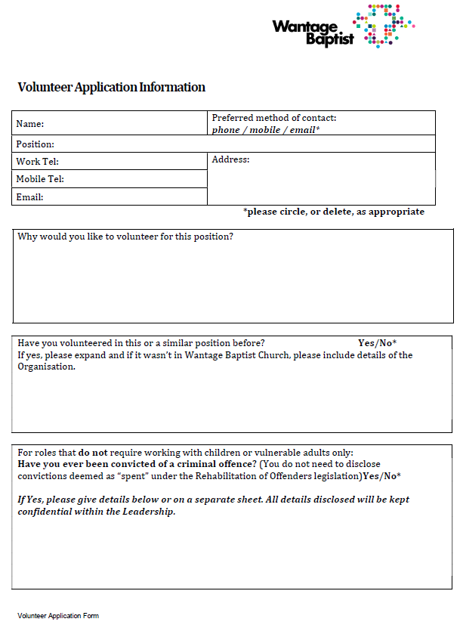
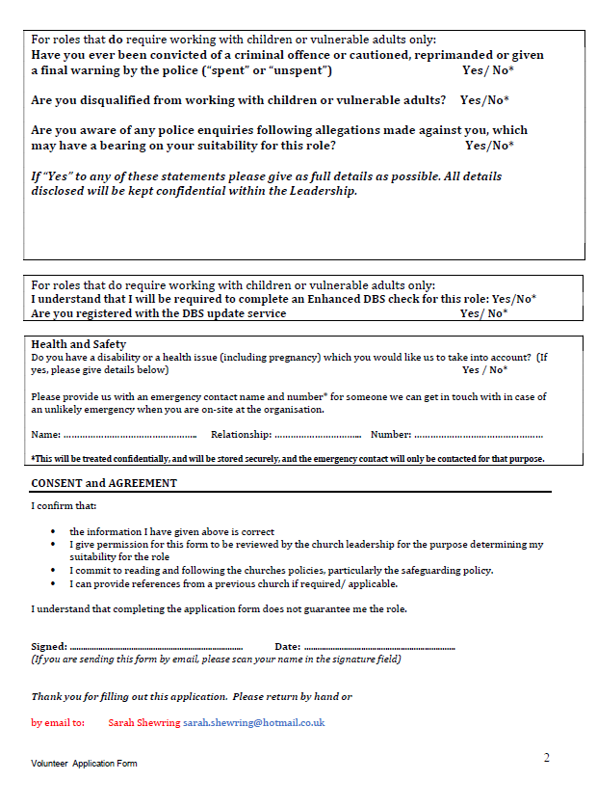

Annex I: Consent Form
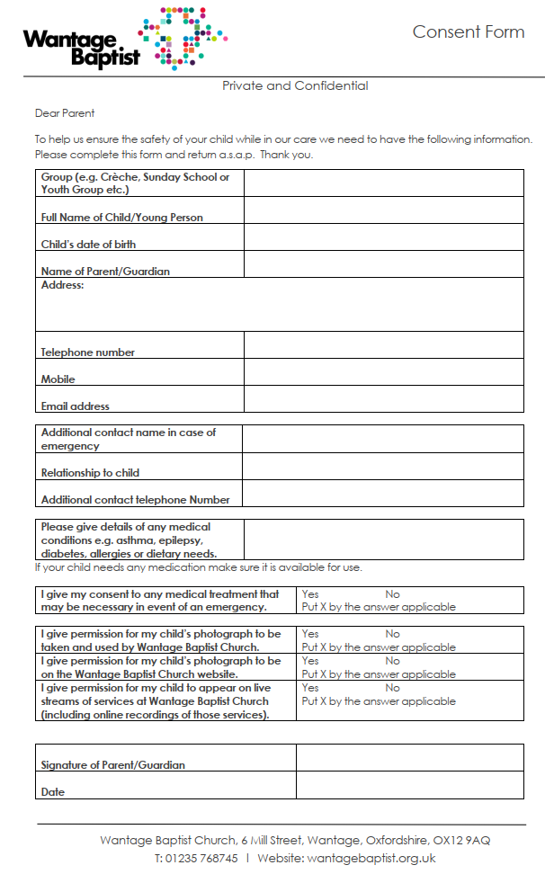

Annex J: Activities and Day Visits Consent Form
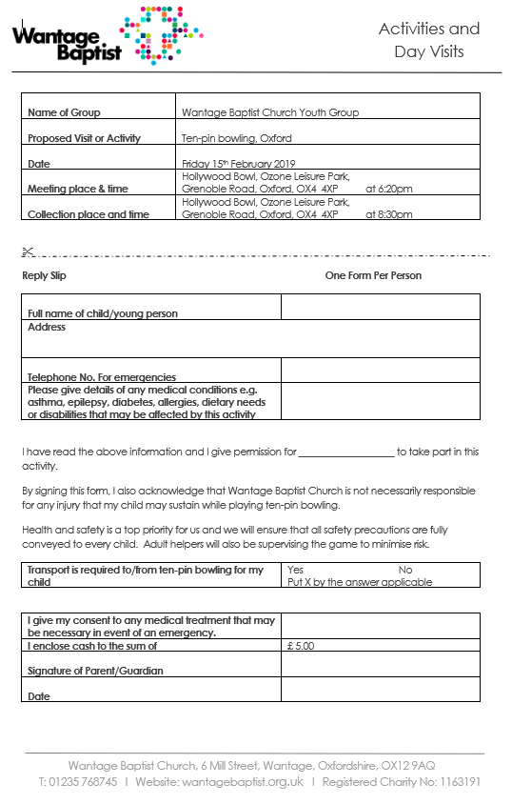

Annex K: Incident Form


